ISLAMIC UNIVERSITY OF TECHNOLOGY
Organization of Islamic Cooperation
Board Bazar, Gazipur

Lab Final Exam
CSE 4512

Step 0:
- Ping result (from PC0 to Web Server)
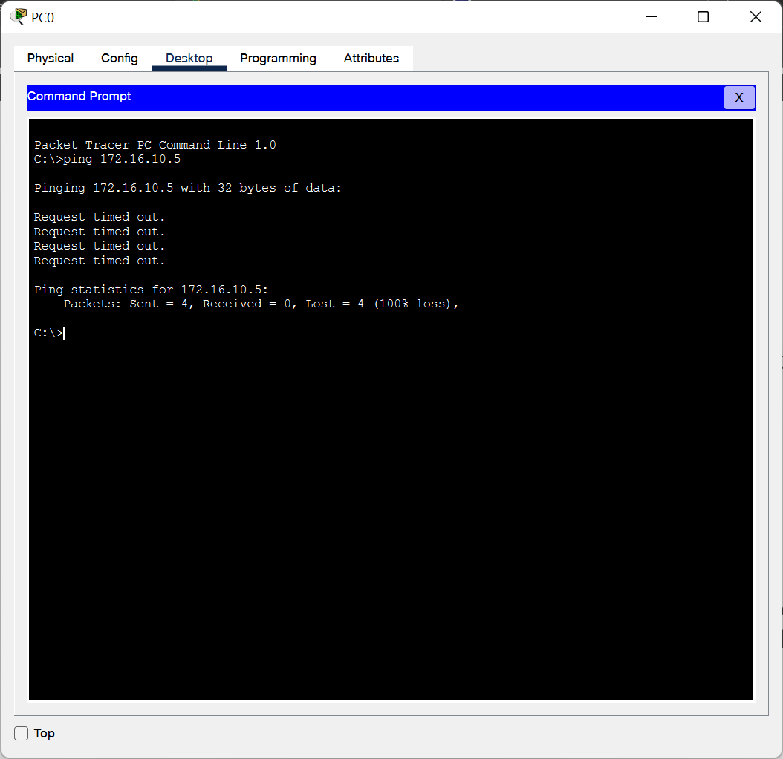
Step 1 (NAT):
- Ping result after NAT configuration (from PC0 to Web Server)
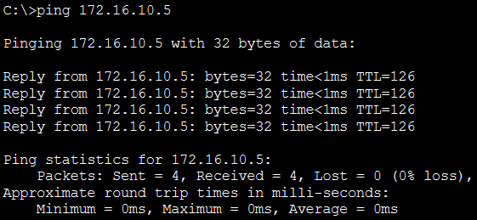
- Command output after above ping (show ip nat translations)
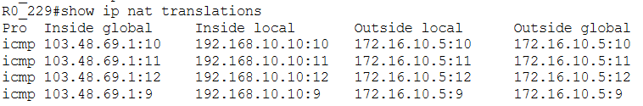
Ping result after NAT configuration (from Attacker laptop to Mail Server)
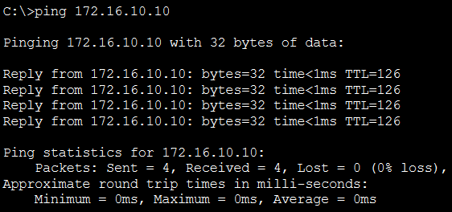

- Command output after above ping (show ip nat translations)
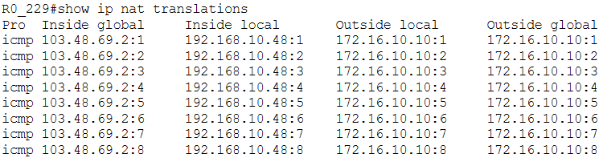
Step 2 (Switch Port Security):
- Command output after disabling all unused ports (show ip interface brief)
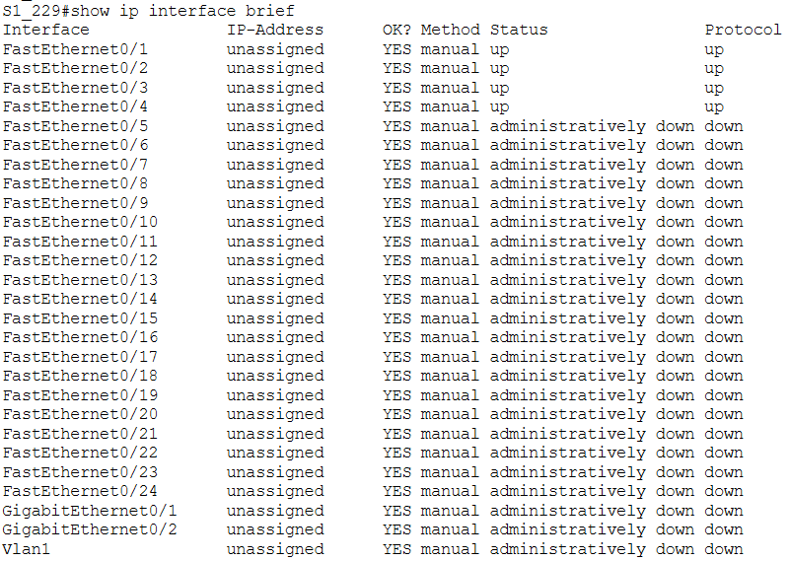
- Command output after configuring switch port security (show port-security)
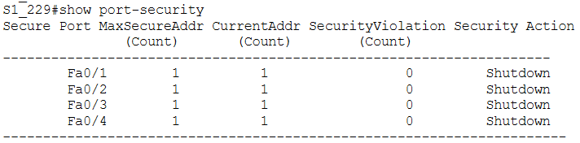

- Command output after configuring switch port security (show port-security address)
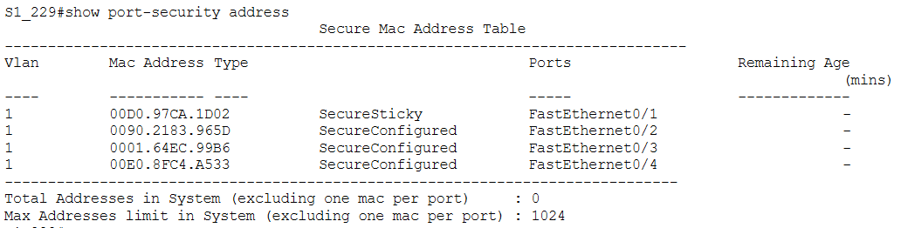
- Screenshot of whole topology after ping (from Intruder laptop to Web Server)
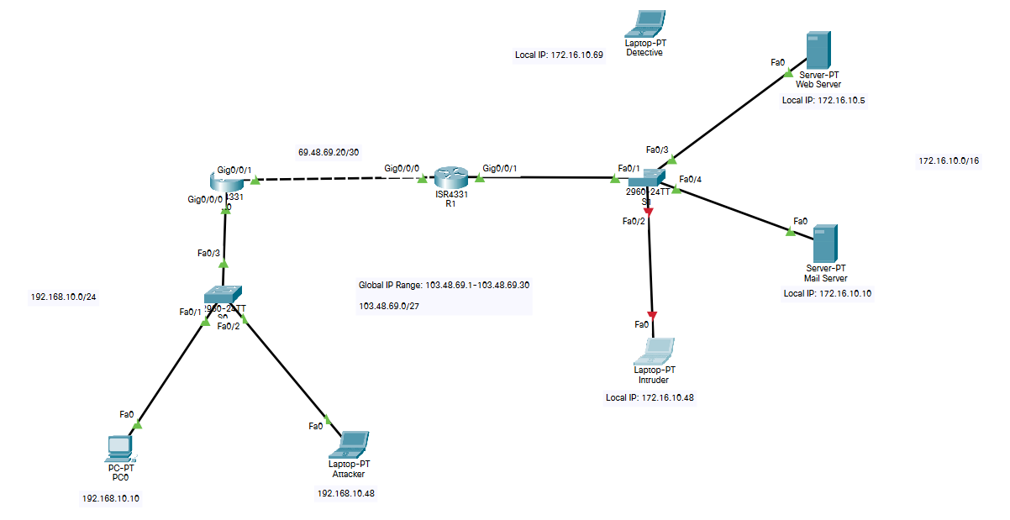
- Command output after security violation from Intruder laptop (show port-security)
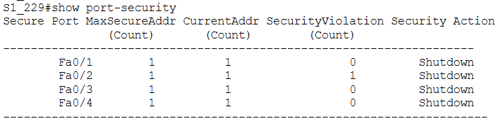

Step 3 (SPAN):
- Command output after configuring SPAN (show monitor)
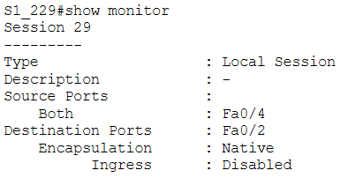
Step 4 (ACL):
- Ping result after configuring ACL (from Attacker laptop to Mail Server)
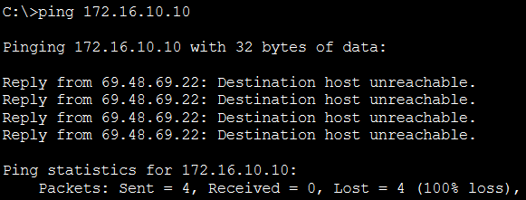
- Command output after configuring ACL (show access-lists)
